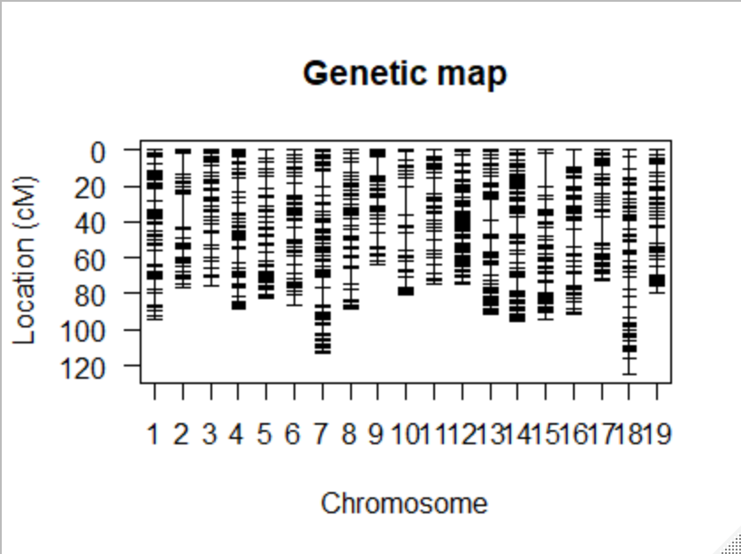

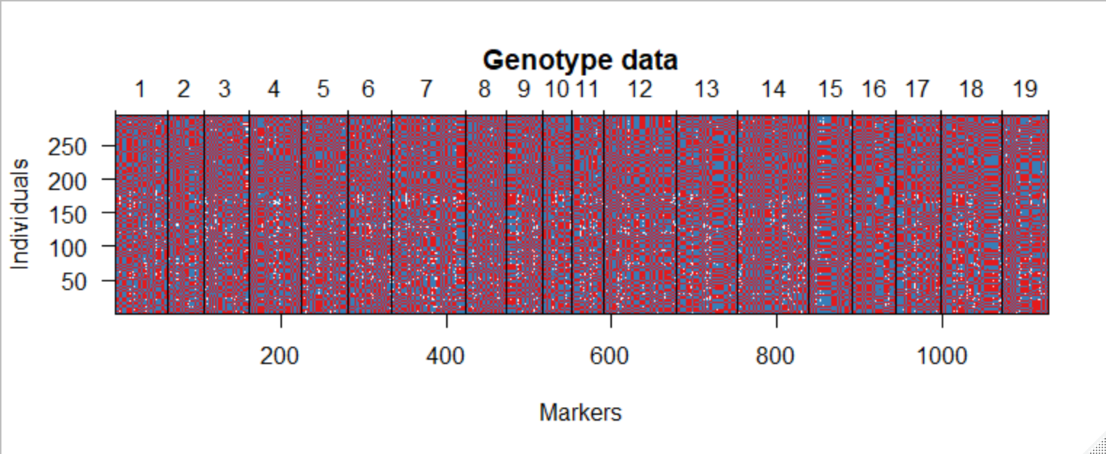

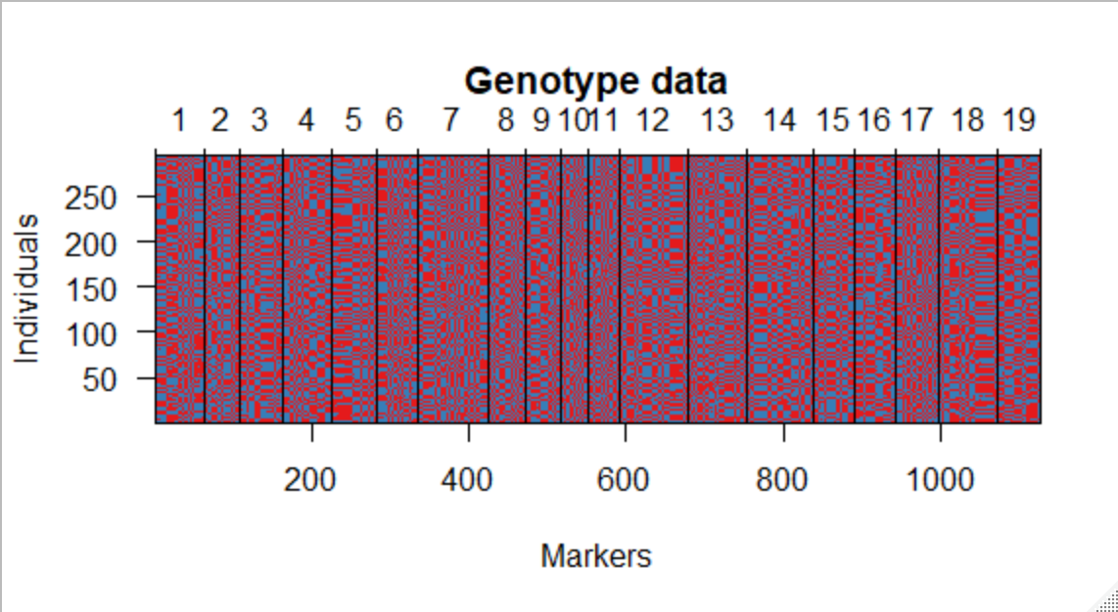

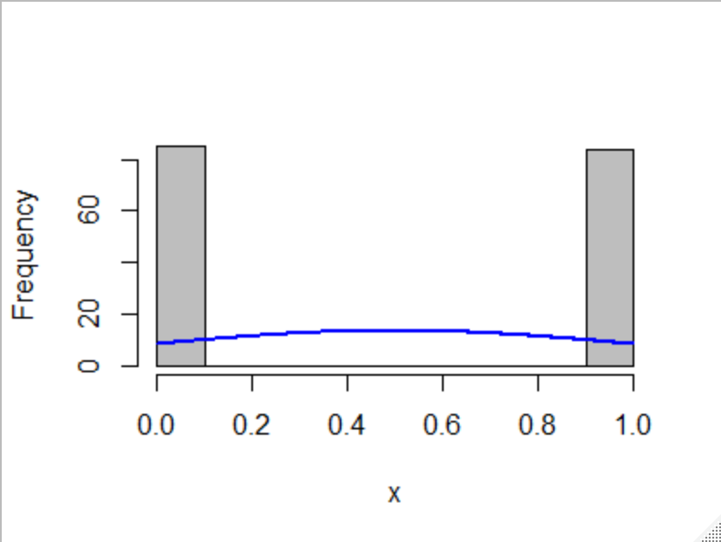

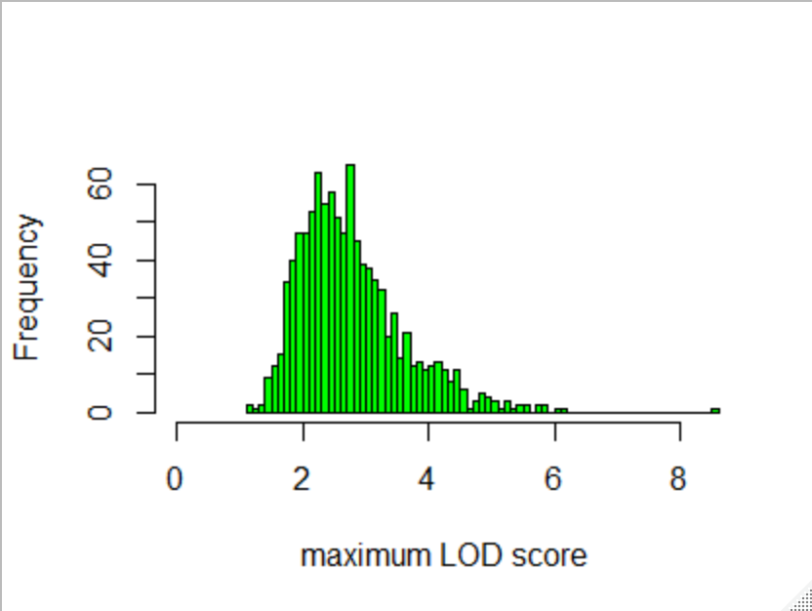

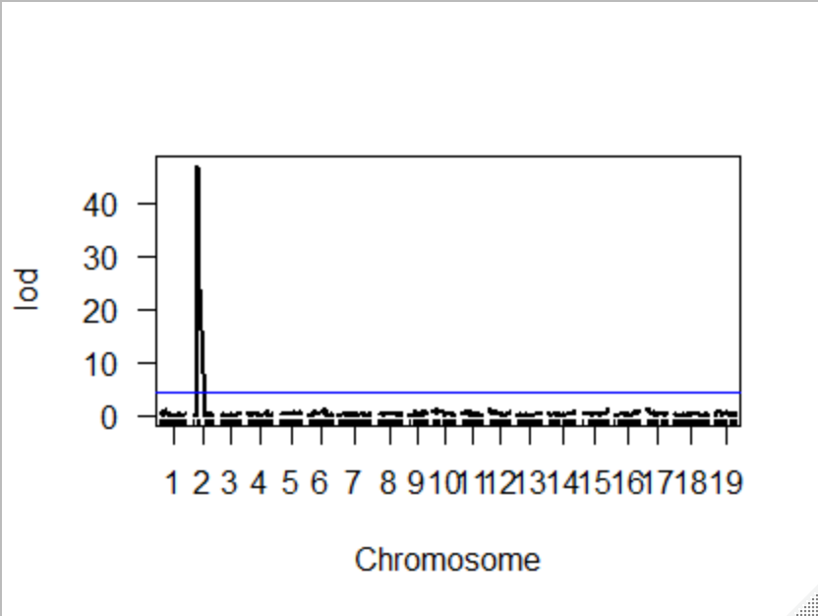

> summary(TraitCIM)

chr pos lod

1_4021184 1 17.999 0.867

2_4272907 2 20.323 46.831

16_9895496 3 70.697 0.196

4_20708423 4 70.015 0.761

5_22057342 5 70.468 0.688

6_16115245 6 58.679 1.192

7_12552225 7 53.543 0.614

8_10222817 8 30.628 0.480

9_5640646 9 24.768 0.840

10_3959571 10 20.132 0.975

11_3968001 11 15.048 0.800

12_769723 12 0.109 1.128

13_22230221 13 74.436 0.381

14_27233180 14 81.057 0.738

15_19559986 15 94.290 1.444

16_20280959 16 75.099 1.077

17_679913 17 2.954 1.195

18_14787621 18 67.438 0.469

19_3090390 19 12.459 0.832

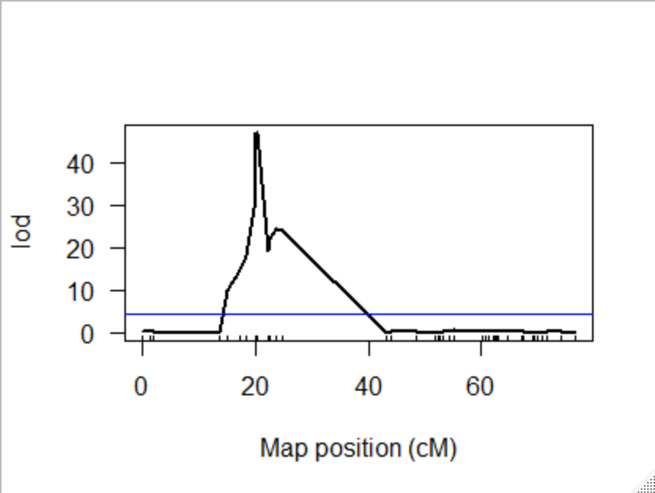

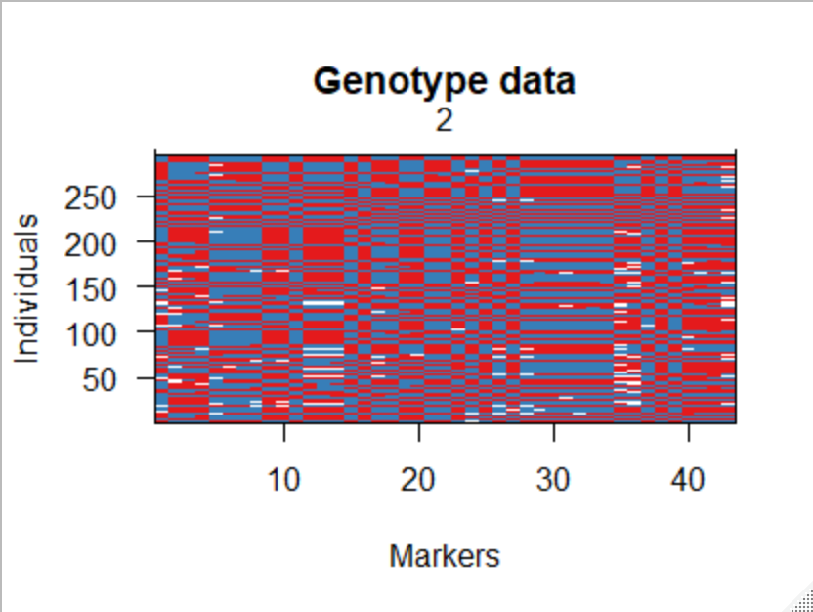

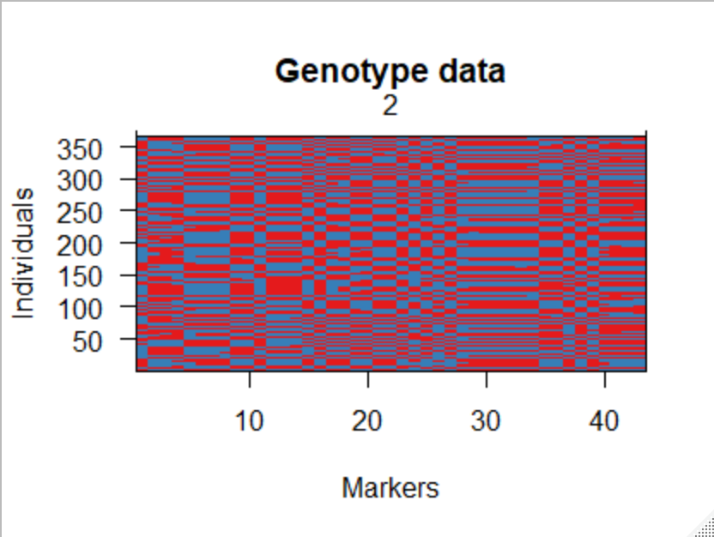

> bayesint(bay, chr = chr, prob=0.95,

+ expandtomarkers=TRUE) #calculate bayesian interval

chr pos lod

2_681715 2 0.00000 0.7217240916

2_4599939 2 22.23201 1.7599686189

2_17017117 2 67.24903 0.0008649556

> lodint(bay, chr = chr,expandtomarkers = TRUE ) #calculate LOD Support interval

chr pos lod

2_681715 2 0.00000 0.7217241

2_4599939 2 22.23201 1.7599686

2_15380310 2 61.42303 0.1305442

fitqtl summary

Method: Haley-Knott regression

Model: normal phenotype

Number of observations : 294

Full model result

----------------------------------

Model formula: y ~ Q1

df SS MS LOD %var

Model 1 24276.49 24276.49 0.295589 0.4619358

Error 292 5231105.00 17914.74

Total 293 5255381.49

Pvalue(Chi2) Pvalue(F)

Model 0.2433231 0.2453366

Error

Total

